**Java Web开发**

**实验三**

**作业报告**

|  |  |
| --- | --- |
| 学 院 | 计算机 |
| 所在系 班 级 | 2017软件工程系9班 |
| 学 号 姓 名 | 13171220 曾创成 |
| 指 导 教 师 | 郭晓燕 |
| 完 成 时 间 | 2019年3月22 |

# 实验题目

将第二章实训题的第二题，登录页面，提交用户名、密码，若用户名不为空字符串且长度在6-8位间，密码不为，空长度为6位，则登录成功，显示“***（用户名）登录成功！”，否则显示“***登录失败”

# 分析与设计

# 关键源码（部分）

代码：

**public** **void** doPost(HttpServletRequest request, HttpServletResponse response)

**throws** ServletException, IOException {

String username = request.getParameter("username");

String password = request.getParameter("password");

request.setAttribute("username", username);

**if** (username.length() < 6 || username.length() > 8 || username == **null**

|| username == "" || password.length() != 6) {

request.getRequestDispatcher("/fail.jsp").forward(request, response);

} **else** {

request.getRequestDispatcher("/success.jsp").forward(request,

response);

}

}

用户名:<input type=*"text"* name=*"username"*><br/>

密 码:<input type=*"password"* name=*"password"*><br/>

<input type=*"submit"* value=*"登陆"*>

<head>

<base href=*"*<%=basePath%>*"*>

<title>My JSP 'success.jsp' starting page</title>

<meta http-equiv=*"pragma"* content=*"no-cache"*>

<meta http-equiv=*"cache-control"* content=*"no-cache"*>

<meta http-equiv=*"expires"* content=*"0"*>

<meta http-equiv=*"keywords"* content=*"keyword1,keyword2,keyword3"*>

<meta http-equiv=*"description"* content=*"This is my page"*>

<!--

<link rel="stylesheet" type="text/css" href="styles.css">

-->

</head>

<head>

<base href=*"*<%=basePath%>*"*>

<title>My JSP 'index.jsp' starting page</title>

<meta http-equiv=*"pragma"* content=*"no-cache"*>

<meta http-equiv=*"cache-control"* content=*"no-cache"*>

<meta http-equiv=*"expires"* content=*"0"*>

<meta http-equiv=*"keywords"* content=*"keyword1,keyword2,keyword3"*>

<meta http-equiv=*"description"* content=*"This is my page"*>

<!--

<link rel="stylesheet" type="text/css" href="styles.css">

-->

</head>

<head>

<base href=*"*<%=basePath%>*"*>

<title>My JSP 'fail.jsp' starting page</title>

<meta http-equiv=*"pragma"* content=*"no-cache"*>

<meta http-equiv=*"cache-control"* content=*"no-cache"*>

<meta http-equiv=*"expires"* content=*"0"*>

<meta http-equiv=*"keywords"* content=*"keyword1,keyword2,keyword3"*>

<meta http-equiv=*"description"* content=*"This is my page"*>

<!--

<link rel="stylesheet" type="text/css" href="styles.css">

-->

</head>

# 运行效果图

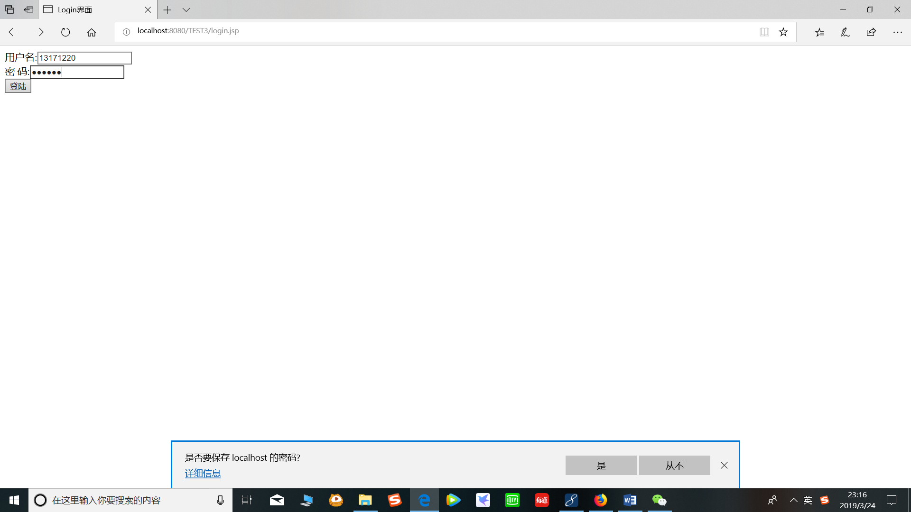

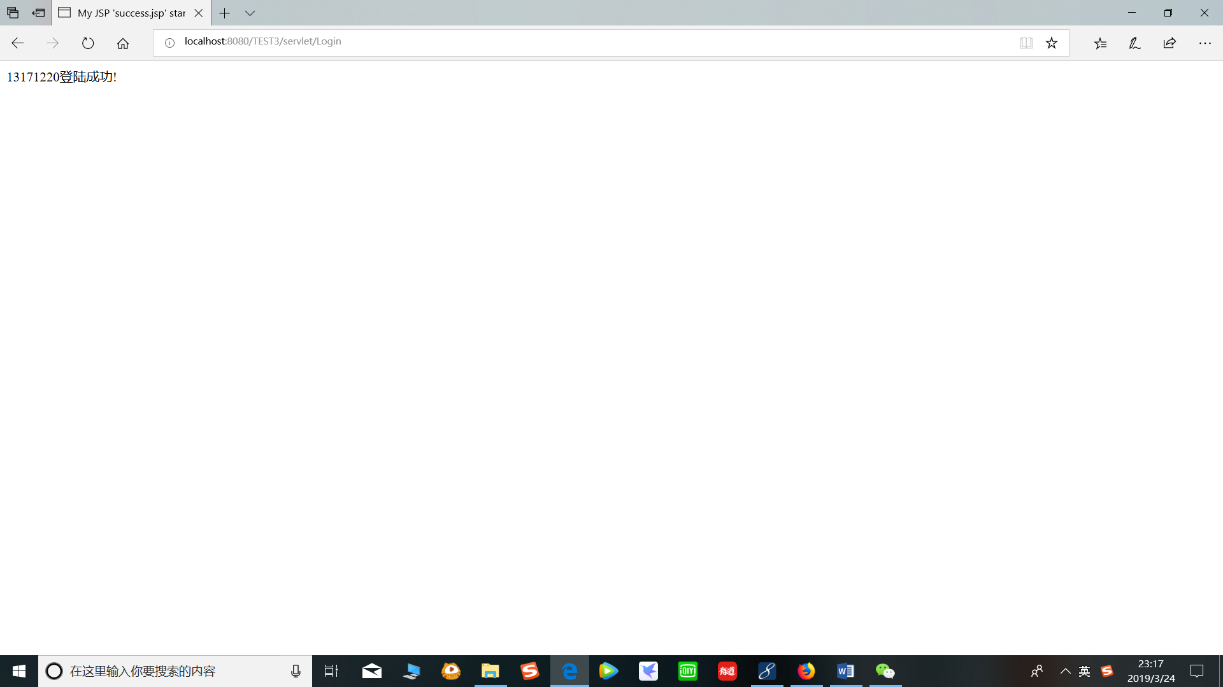

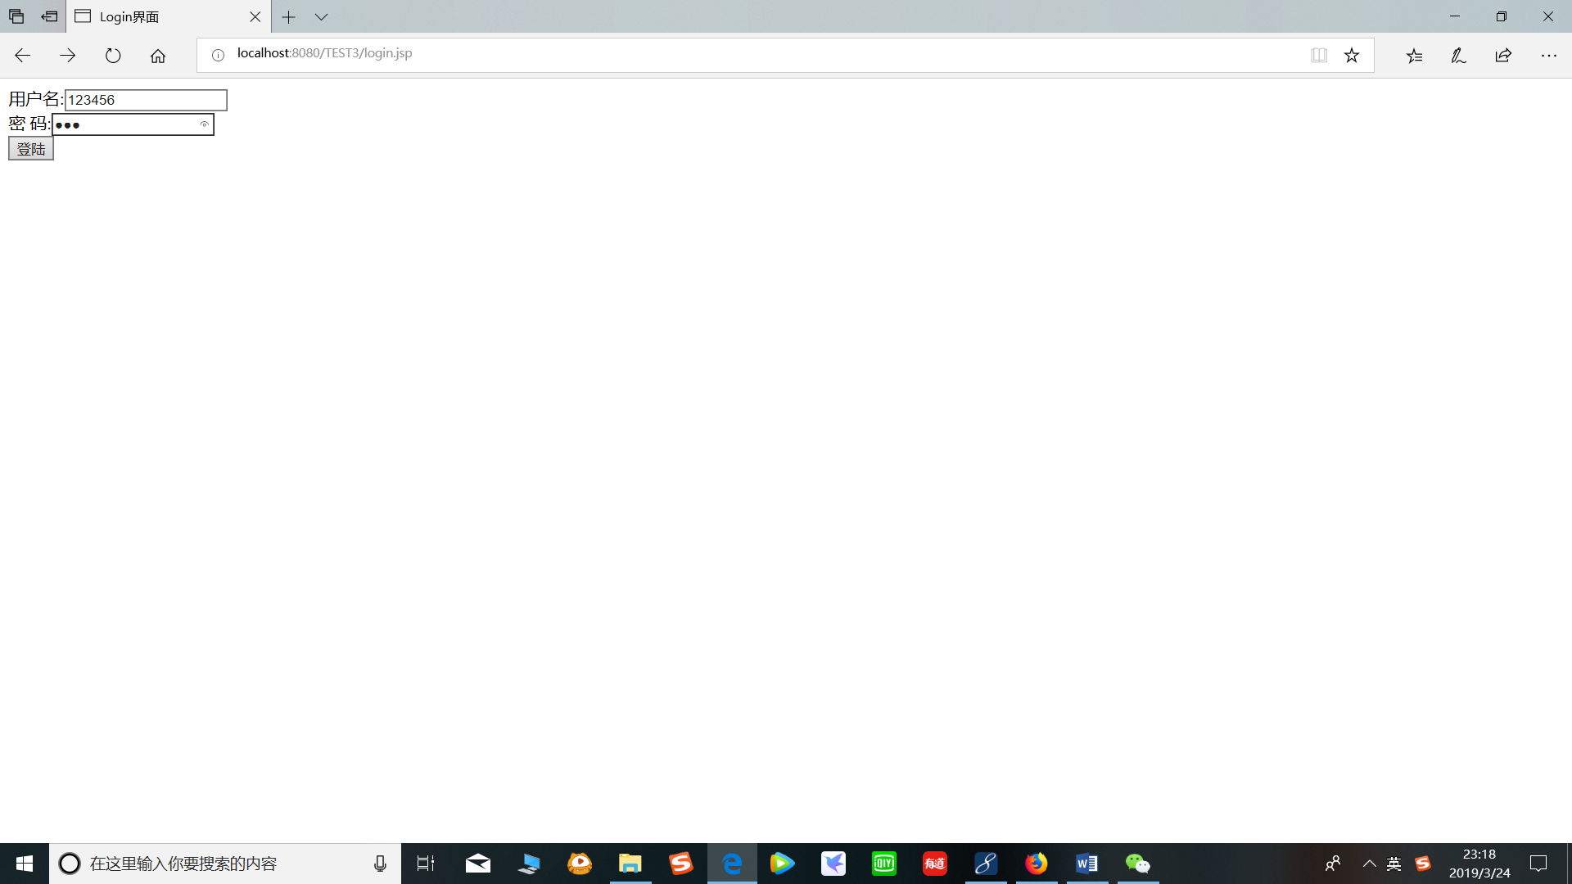

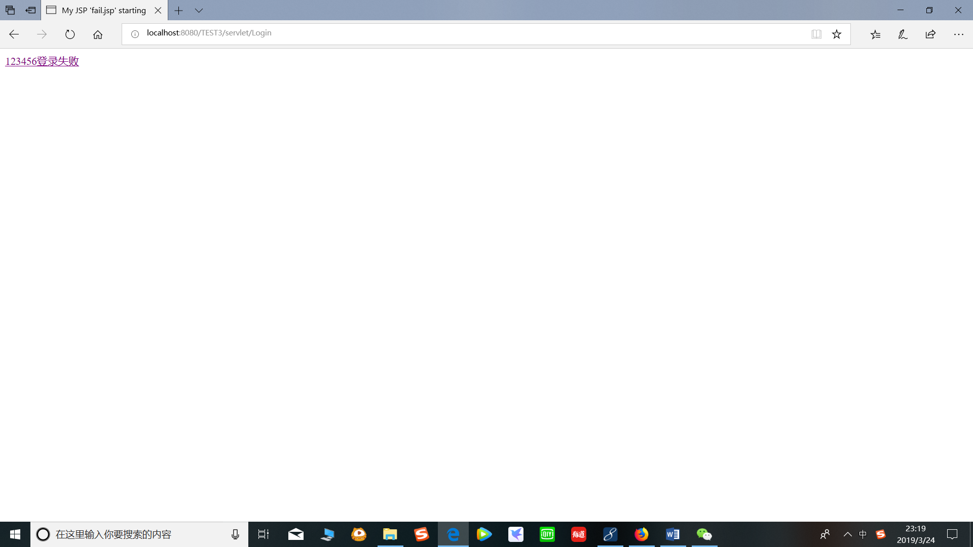

# 收获与问题